**Phasor-sFLIM manual**

1. Extract the “Phasor_sFLIM.zip” file

1. Open “Phasor_sFLIM_gmm.m”, you need to define the number of clusters for the unmixing algorithm. In the demo for this manual, the number of clusters was set to 2

1. Run “Phasor_sFLIM_gmm.m”, the software will ask you to select the sFLIM data file. Select “convallaria_ex_488_650nm_256_200umFOV2_Intensity_Ch1.tif”, the software automatically 16 .tif file for 16 spectral channels.A screenshot of a computer

   Description automatically generated
2. The software will generate intensity images for each spectral channel.

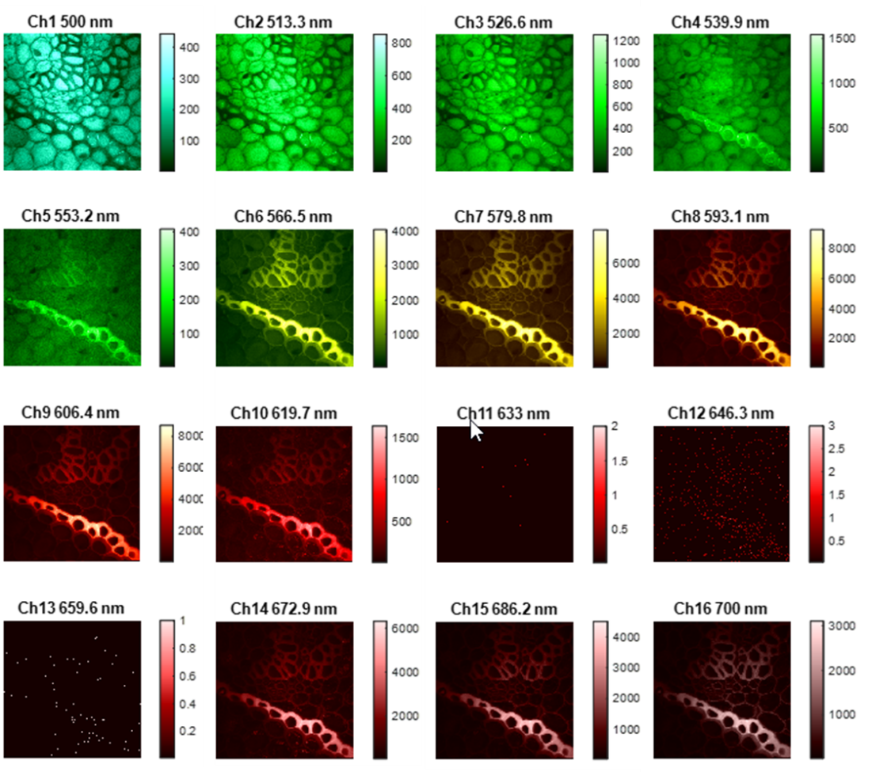

1. Unmixing based on spectral phasor. You will need to select the intensity threshold; default value is 0.3.

After finishing unmixing process, the software will visualize unmixed data on spectral phasor plot, intensity images and lifetime images for each cluster. Here is the example results with cluster number set to 2:

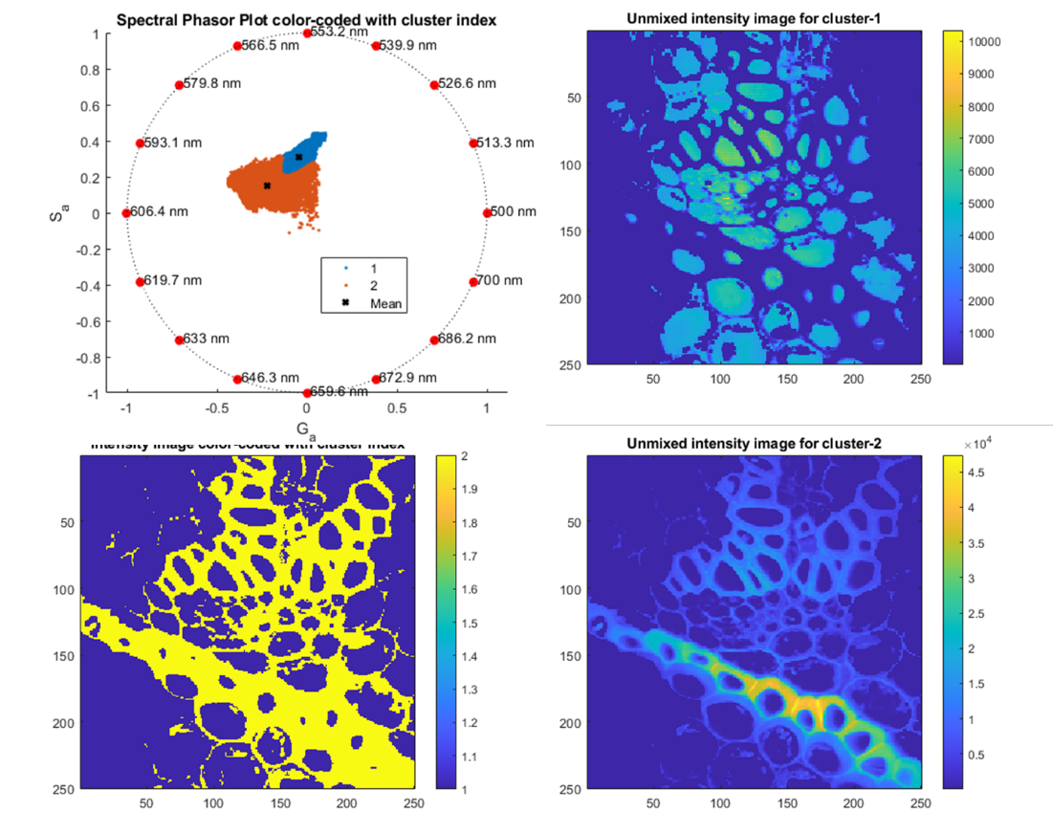

1. Unmixing based on lifetime phasor - green emission band. You will need to select the intensity threshold; default value is 0.1.

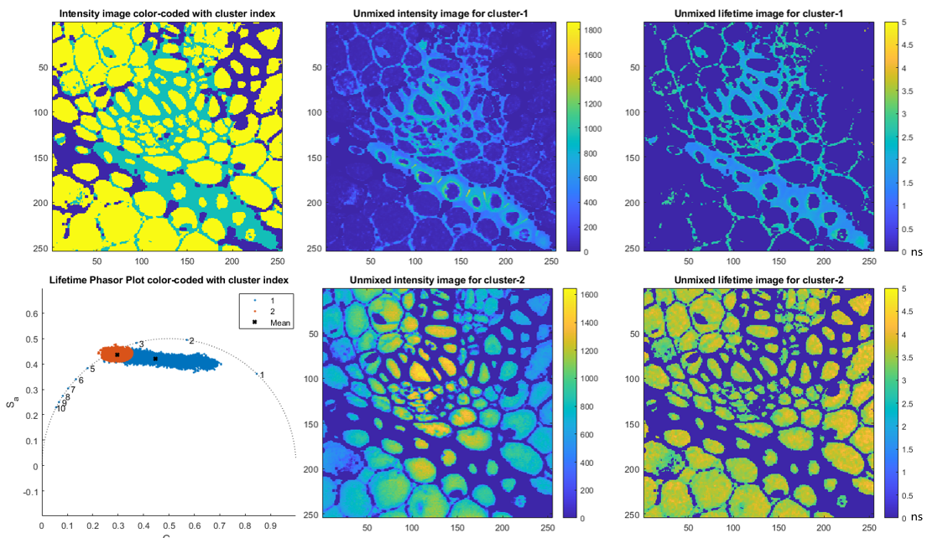

1. Unmixing based on lifetime phasor - orange emission band. You will need to select the intensity threshold; default value is 0.1.

1. Unmixing based on lifetime phasor - red emission band. You will need to select the intensity threshold; default value is 0.1.

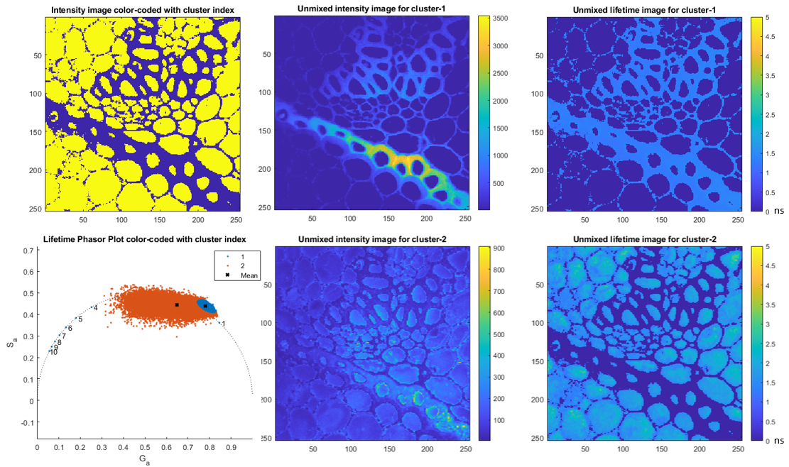

The Phasor_sFLIM_gmm code and the addons, scripts and functions supporting code were developed by Ted Nguyen (Yeh’s group, UT Austin).

The flimtools supporting code were developed by Lorenzo Scipioni (Gratton’s group, UCI).